COA GUI TESTING PLAN

Prepared by:

Jian Fu
Date: 6/6/2005
Table of Contents
GUI Testing 3
Description 3
Test Cases 3
Start Auction on Strategy Classes 3
View Auctions 3
Respond an Auction 3
Screen snapshot 4
Add New Order Dialog Screen 4
Auction Display Window Screen 5
Auction Response Dialog Screen 6

GUI Testing

Description
The Auction Display window will keep track on the automated auction started on the quoted products of subscribed strategy classes. Auction response dialog gives the ability to send a response from GUI.

Test Cases

Start Auction on Strategy Classes
To start an auction, select a product on Market Display:
- Select Order -> Add New Order from pop up menu; or,
- Select Add New Order from Order menu;

To start the auction, for example, a strategy order with two legs Leg1 and Leg2 and the quotes on the legs are:
Leg1: 2:00 - 2.40, 100X100
Leg2: 1.20 - 1.40, 100X100

The calculated derived quotes will be (-0.60, 1.20). So if send a strategy order on the same side, then enter price -1.20 to start the auction (Figure 1); if send the order on the opposite side, then enter price 0.60 to start the auction.

After successfully submit the order, verify the Auction Display window will have one new entry (Figure 2).

View Auctions
To view auctions, user needs to create a new Auction Display window from the main menu, and add the strategy class from View menu on Auction Display window (Figure 2).

Make sure to select strategy as auction type in the Class Selector dialog.

Make sure that only the user(s), who subscribed to the class with strategy auction type and quoted on that product, will be able to see the auction started on that product, no matter whether she/he initially started the auction or not.

Respond an Auction
To respond an auction displayed on Auction Display window, user must select one auction and pull up the response dialog from menu Order -> Response to Auction.

Verify that on auction response dialog, the contingency field is set to AUCTION RESPONSE and disabled, side is selected, and fields are pre-filled based on the auction (Figure 3).

Screen snapshots

Add New Order Dialog Screen
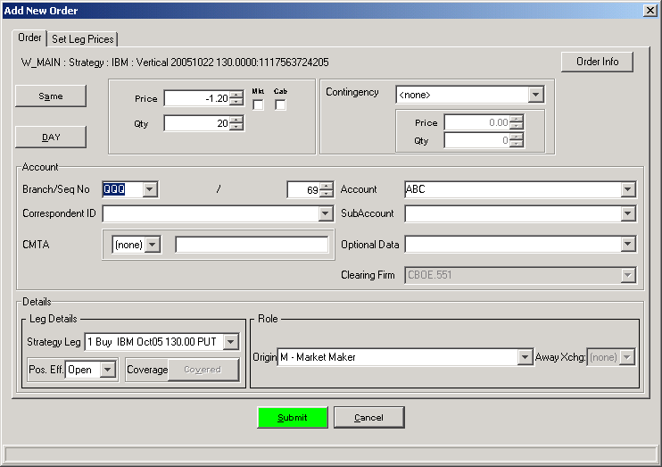
Figure 1 Sample Order to Start Auction Process on Market Display Window

Auction Display Window Screen
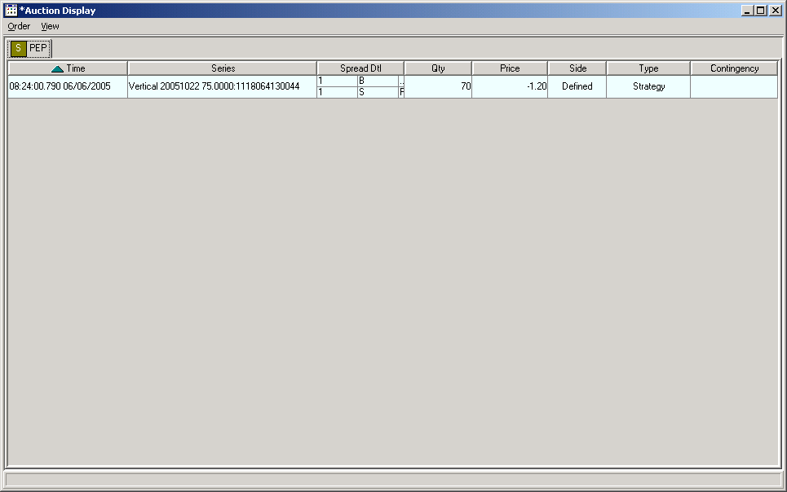
Figure 2 Auction Display Window with Auctions on Strategy Class

Auction Response Dialog Screen
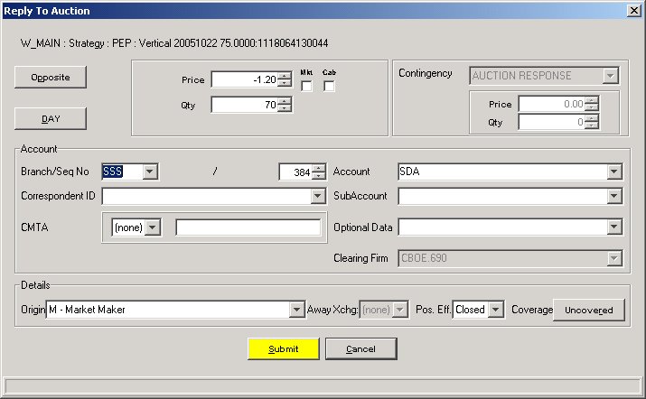
Figure 3 Auction Response Dialog

